Our new offers:
For the winter season of 2023, through until April 2024, we are offering group booking discounts for hire of bikes on the trail. Helmets, locks, and map included in the hire price.

Junior bike and drink:
For junior school bookings, and any other groups of juniors over 10 people. we are offering a rate of £12 per bike for half a day (4hrs), this will also include a hot drink from the café for after your ride. (Drink options include cold drinks, cans etc if required).

Junior bike no drink:
If drinks aren’t needed or wanted, we are offering just £11 a bike for the half day.

Adult bookings:
For adult groups, be it a stag or hen do, a large group of friends or a works day out, we are offering a rate of £18 per bike for the 4hrs. (excludes E bikes). On groups over 10.

Adult E bike bookings.
The same as above, but the ease of an electric bike, for just £25 per bike for the full day. On groups over 10.

How to book:
If you have received this offer sheet, you are then eligible to call or email back with a date and a booking, quoting the offer stated, and we can get you booked in and invoiced for the hire.

About the trail:
The Monsal Trail is a traffic-free route through spectacular limestone dales with incredible views. The trail is 8.5 miles long, the route follows the former Manchester to London Railway line, closed in the late 1960s. Cyclists love the Monsal Trail for its easy access and flat surfaces through White Peak hills and dales. There are several refreshments stops along the way.

About us:
Within the Hassop Station facility is the Monsal Trail Cycle Hire Centre. We are situated near the start of the monsal trail, with year-round bike hire, you could soon be experiencing the unique Monsal Trail aboard one of our quality cycles or electric bikes.
Where we are:
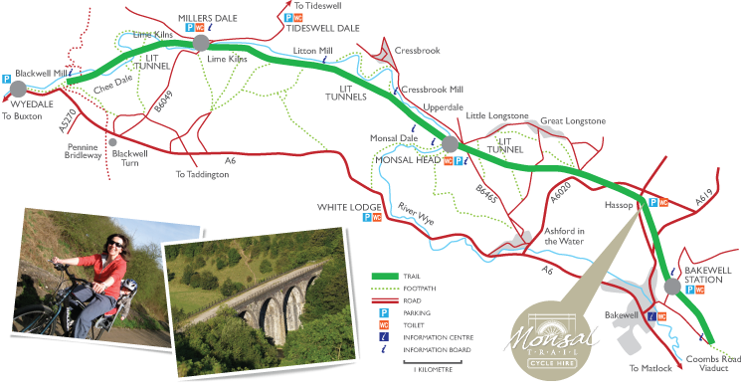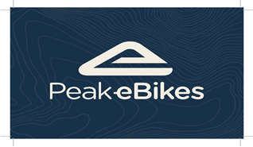
Monsal Trail Ltd. Hassop Station,
Bakewell, Derbyshire, DE45 1NW
cycle@monsaltrail.co.uk, 01629810588
BACS: Monsal Trail Ltd. Sort: 08.92.99 Ac.69950887
VAT registration Number : 131363056
Company Registered in England Number: 07557225

